BIT 4107 – Mobile Application Development
ENHANCED PROFESSIONAL STUDENT LOGBOOK
Student Name: ___Nzomo Felix___________________________
Admission Number: ____BIT/2024/56040__________________________
School/Faculty: _____Computing and Infromatics_________________________
Programme: _________BIT_____________________
Academic Year: _____3_________________________
Semester: __________2____________________
Lecturer: ________Mr._Nyoro_____________________
Phone Number: __________0713682055____________________

Instructions
This logbook is used to document weekly learning activities, practical exercises, skills acquired, challenges encountered, solutions applied, and reflections. Students should complete all sections every week.
Each week to follow remarks in week 1 section.

Autogenerated Table of content

Week 1: Introduction to Mobile Application Development
Week 1 Report Objectives
- Install Android Studio
- Create first Compose app
- Customize UI elements
Activities Done
- Set up Android Studio + Compose project
- Created Splash Screen
- Built modern Login Screen with gradient
Challenges
- Learning Jetpack Compose syntax
- Managing navigation state
Solutions
- Used LaunchedEffect for splash
- Applied Material 3 design
Screenshots
- Android Studio project open with the mainactivity.kt code
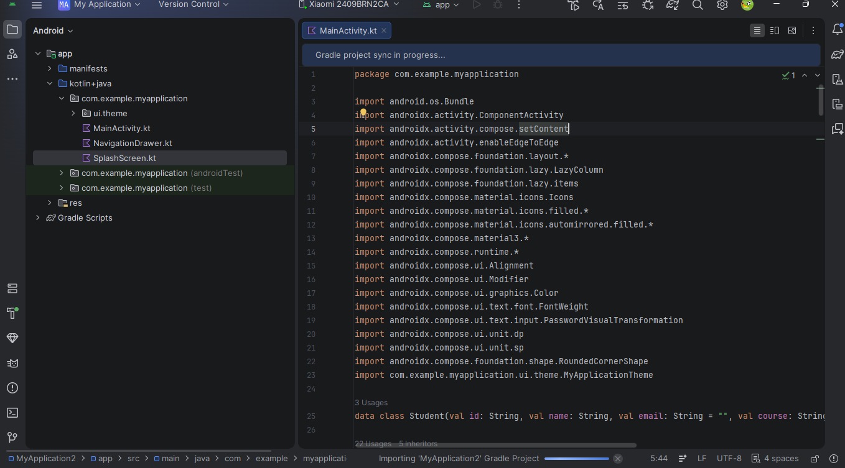
Reflection Successfully completed first mobile app using Jetpack Compose.

Week 2: Mobile Development Environment
Week 2 Report Objectives
- Build Mini EduPilot App
- Multiple screens + navigation
- Basic data handling
Activities Done
- Implemented Login, Register, Dashboard
- In-memory data storage
Challenges
- Screen navigation
- State management
Solutions
- Used sealed class for screens
Screenshots
- Login Screen
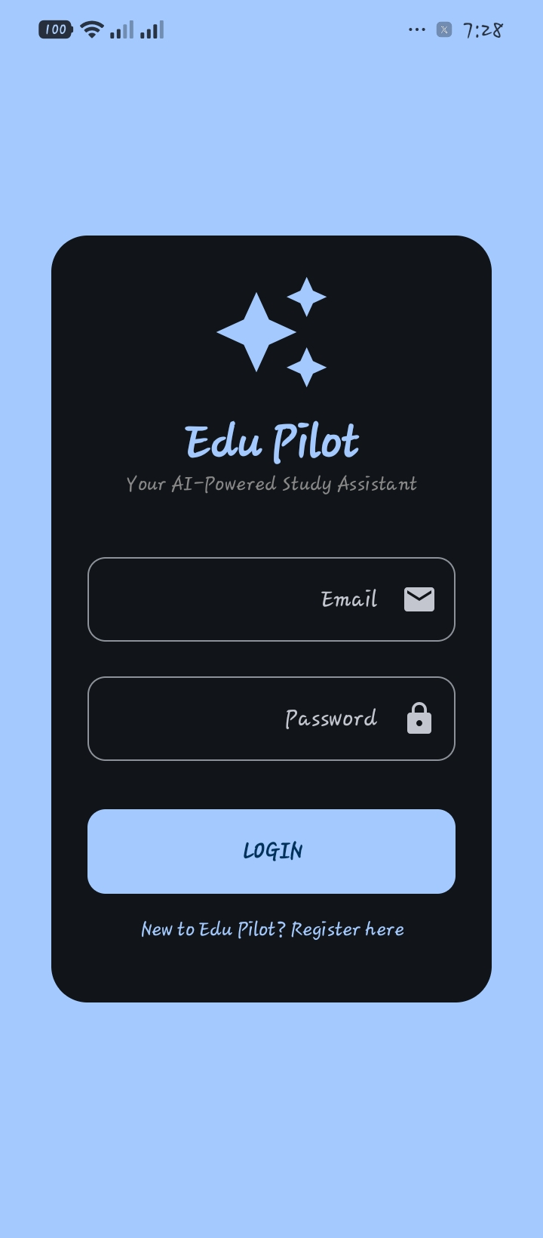
- Dashboard

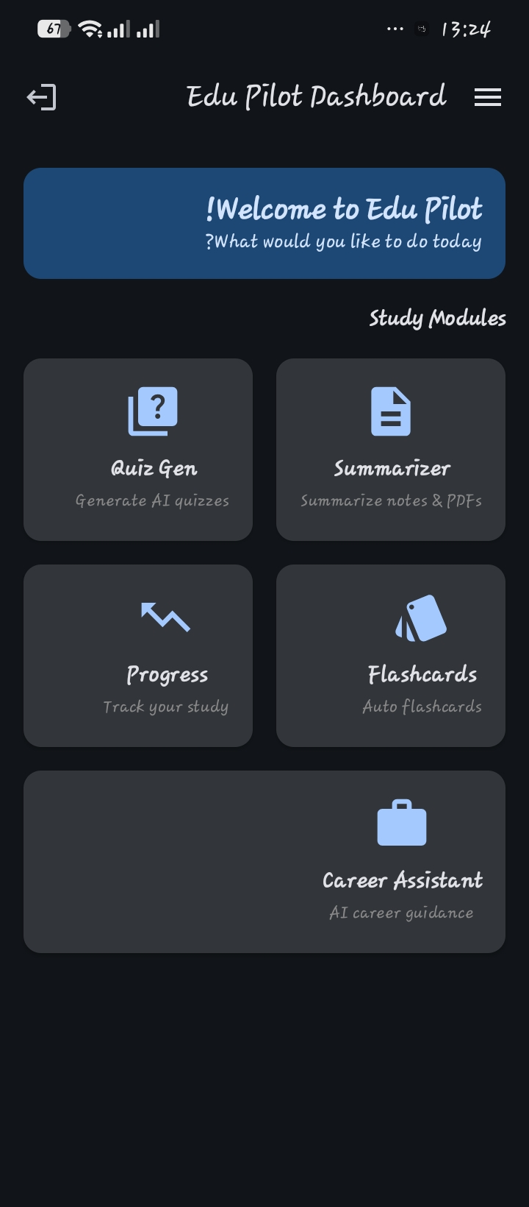
Reflection Learned basic app architecture and state management in Compose.

Week 3: User Interface Design
Week 3 Report Objectives
- Modern UI/UX Design
- At least 5 screens
- Professional look & feel
Activities Done
- Added Splash Screen
- Improved Login with gradient
- Created Dashboard with stats
- Added Profile Screen
Challenges
- Making UI beautiful and consistent
- Proper spacing and theming
Solutions
- Applied Material 3 + Rounded shapes
- Used icons and good typography
Screenshots
- Dashboard Screen

2.Profile / Navigation menu
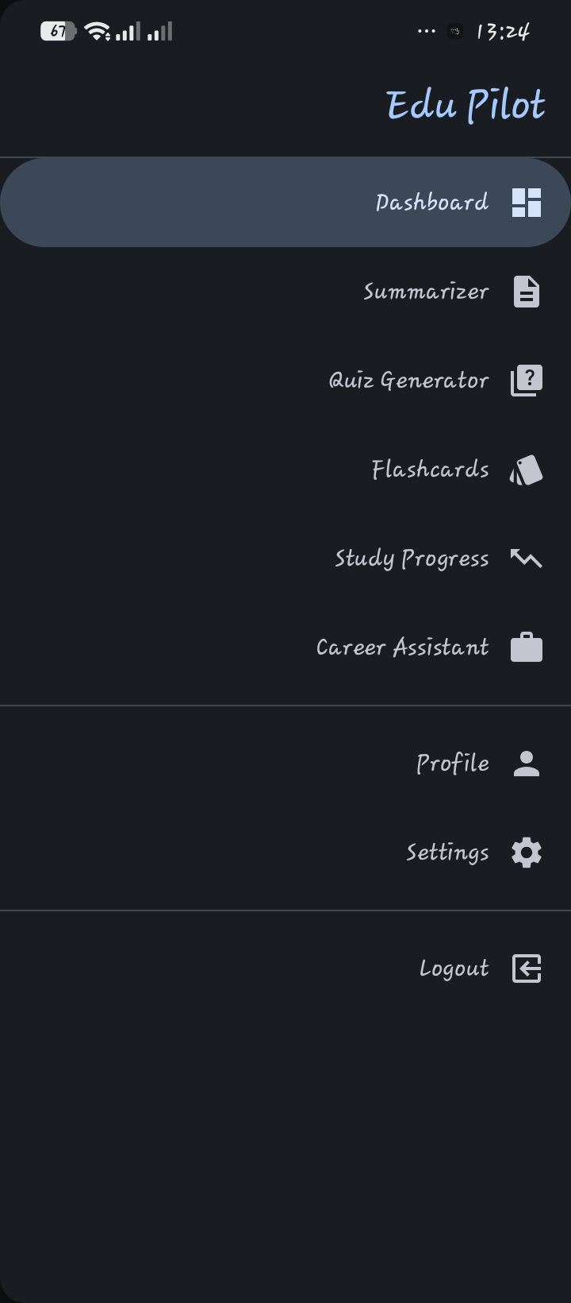
Reflection Improved UI/UX skills significantly. App now looks professional.

Week 4: Event Handling and User Interaction
WEEK 4 DOCUMENTATION
Search
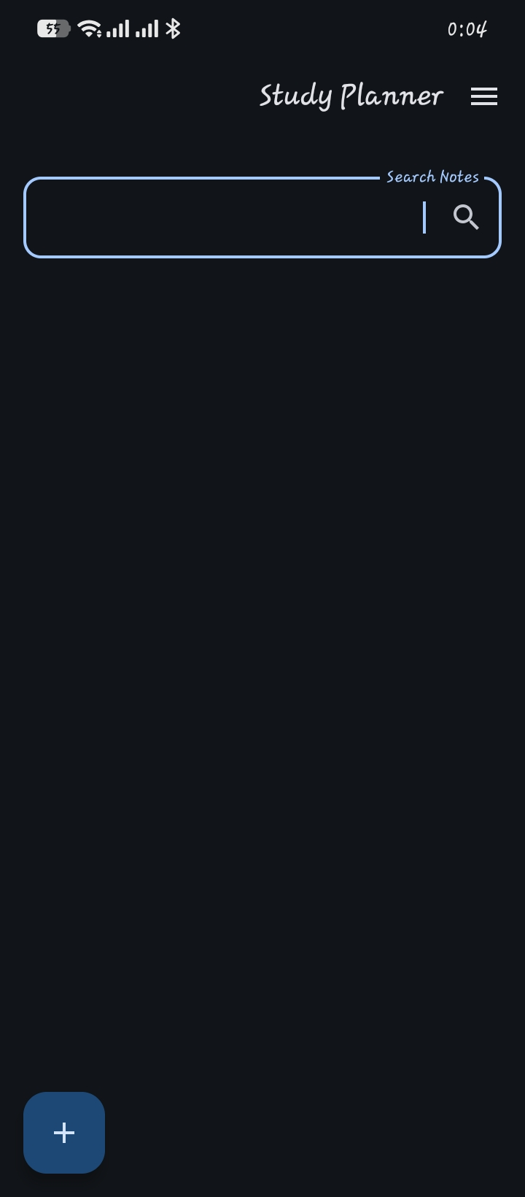
Results
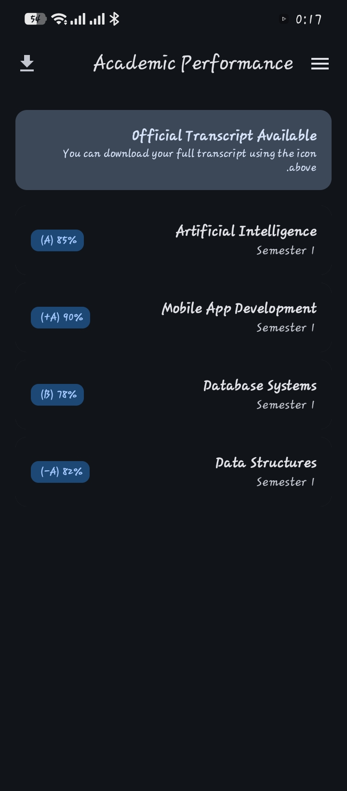

Week 5: Data Management
Dashboard with Global Resources
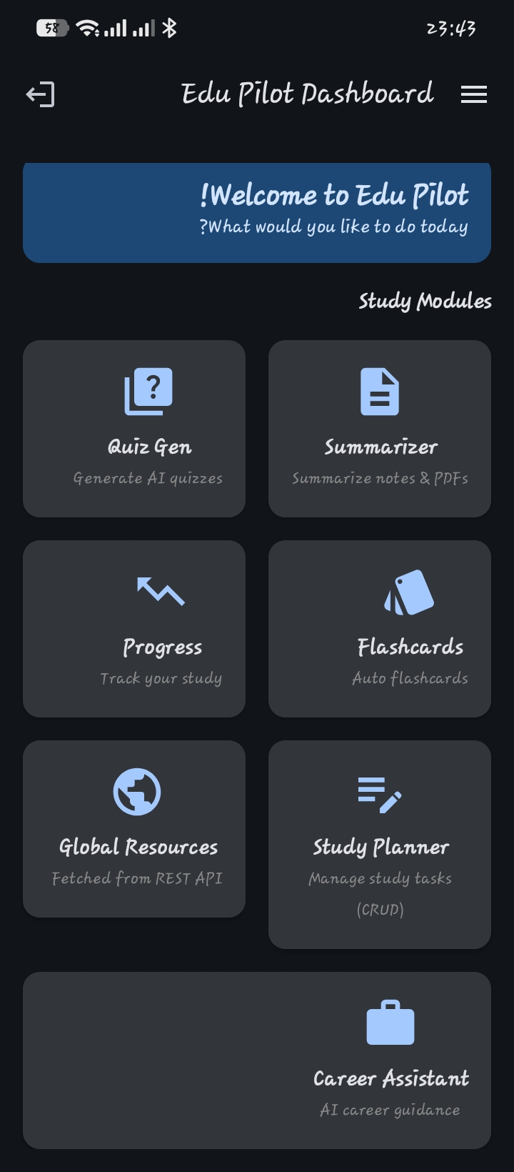

Week 6: Networking and APIs
Networking
Global Shared Resources
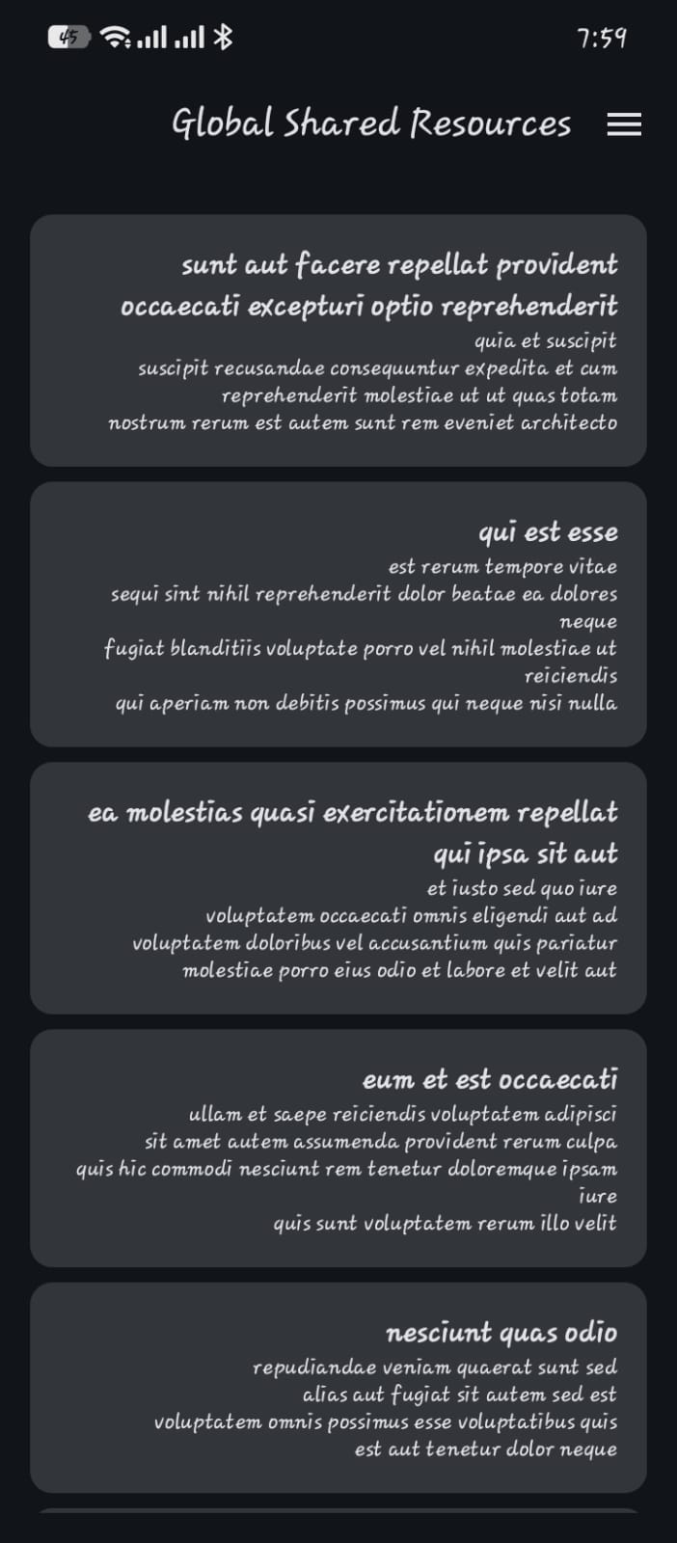
REFLECTION:
Mastered REST API integration using Retrofit and Coroutines. I implemented robust state management for loading/errors, ensuring Edu Pilot fetches real-time data efficiently. This enhances UX by providing seamless, non-blocking access to external study resources.

Week 7: Application Architecture
Retrieve Results and Download Documents


Week 8: Project Planning
Interaction Lab
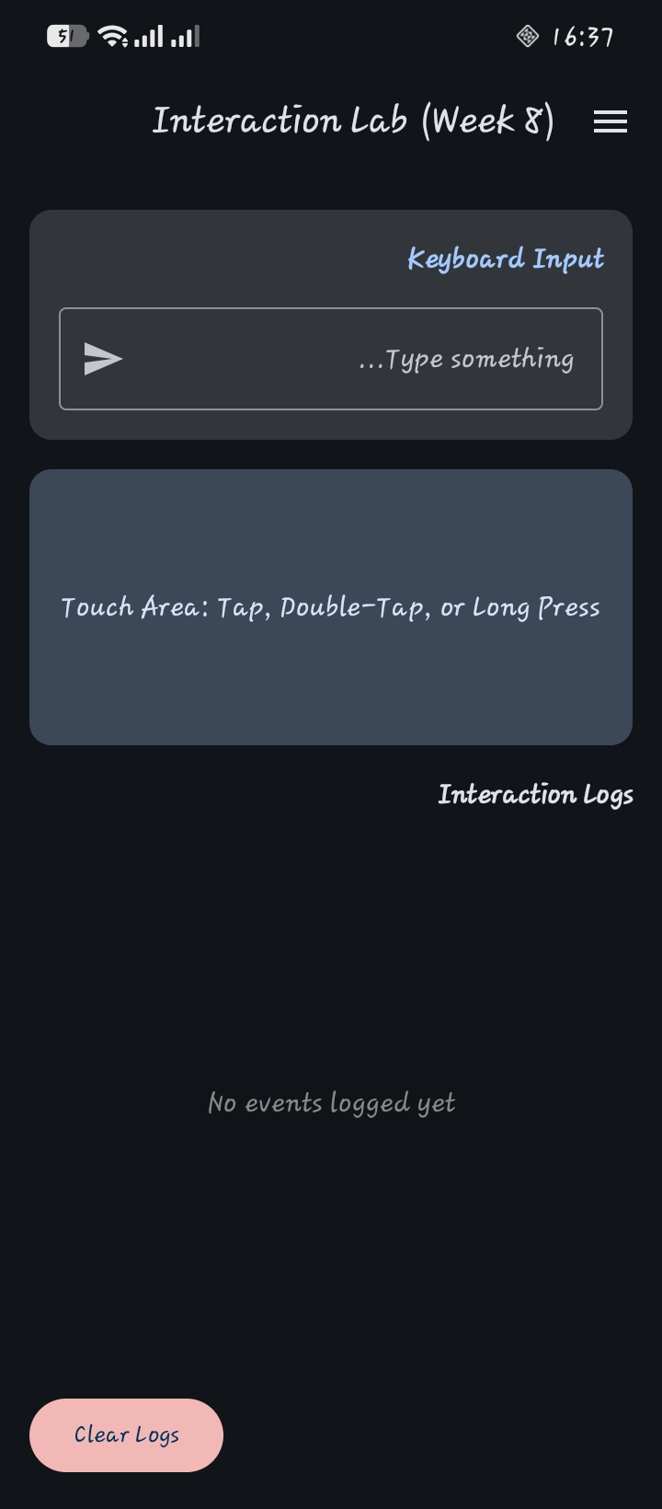
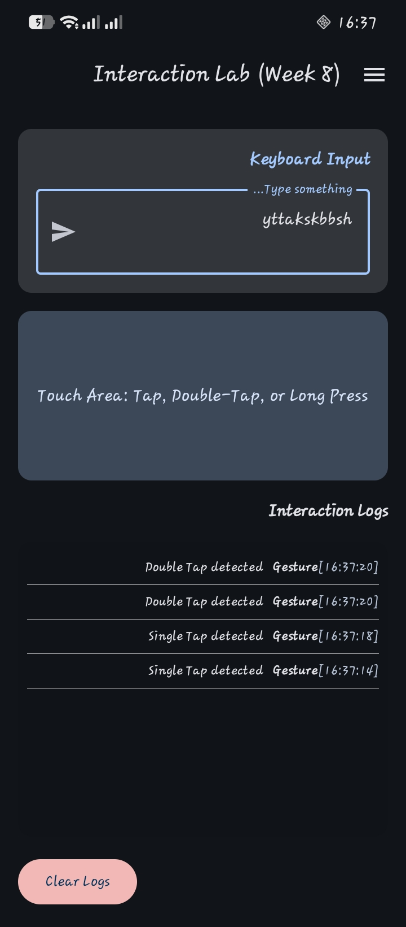

Week 9: Device Features and Sensors

Same as week 1

Week 10: Notifications and Background Services

Same as week 1

Week 11: Mobile Security

Same as week 1

Week 12: Testing and Debugging

Same as week 1

Week 13: Application Deployment

Same as week 1

Week 14: Final Project Presentation

Same as week 1

Semester Project Tracking

Project Title

Project Objectives

Project Requirements

Development Milestones

Testing Results

Lessons Learned

Future Improvements

End of Semester Reflection

Summary of Skills Acquired

Most Interesting Topic

Major Challenges Faced

How Challenges Were Overcome

Professional Growth Achieved

Overall Course Experience

Final Approval
Student Name: __________________________
Student Signature: ______________________
Date: _________________________________
Lecturer Name: _________________________
Lecturer Remarks: _____________________
Date: _________________________________

